AD LIFECYCLE ARTIFACT | External Design Document – V4.3  Detail Component Design
Application: OMS | Project Name: Order Management System
Module/Component/Executable:  Process Plan | Project Initiation Code: OMS
Author: Thomas Thomas | Project Code:
Language: Java | Time Tracking Code:
The Internal Design describes the new module or modifications to an existing module to meet the desired functional changes as specified in the External Design. The document should reference all aspects of the module being modified including detailed references to inputs and outputs. The document should also include test-planning guidelines to support Unit Testing.
1 VERSION HISTORY 2
2 OVERVIEW 2
2.1 Summary 2
2.2 Out of Scope 2
2.3 Architecture Overview 3
2.4 Detailed View 4
3 REQUIREMENTS TRACEABILITY MATRIX 5
4 FUNCTIONAL & LOGICAL SPECIFICATIONS 6
5 DESIGN ASSUMPTIONS. 8
6 DESIGN RISKS. 8
7 ARCHITECTURE IMPLICATIONS 8
8 DATABASE MODEL 8
9 QUALITY CONTROL 9
10 INTERNAL DESIGN SIGNOFF (AD Only) 9
11 APPENDIXES 10

VERSION HISTORY

Version | Description of Changes | Date | Author
1.0 | Initial release | 9/6/05 | Thomas Thomas

OVERVIEW

Summary

This document describes the OMS process of creating a process plan at a high level and its interactions with system outside of OMS. (Specific to Iteration 2 end to end integration)

Out of Scope

N/A

Architecture Overview

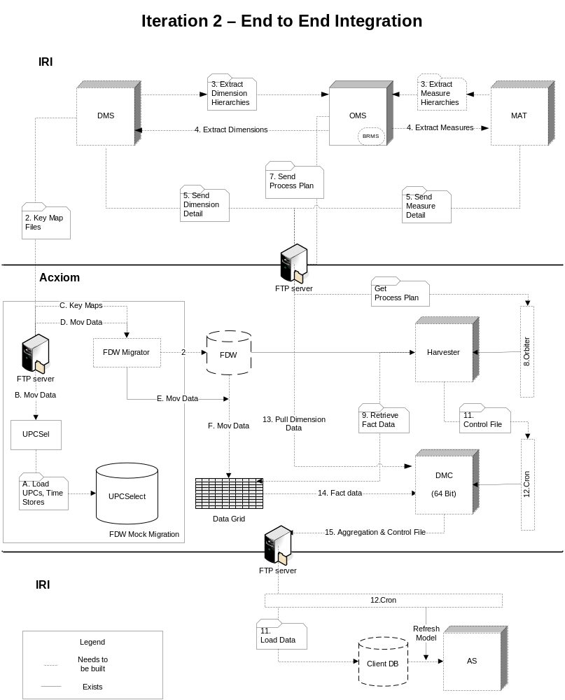

Detailed View
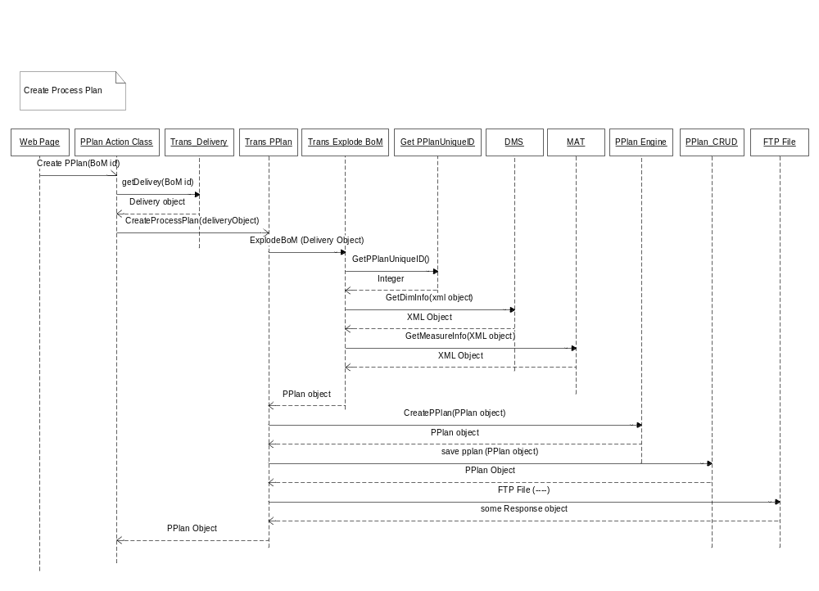
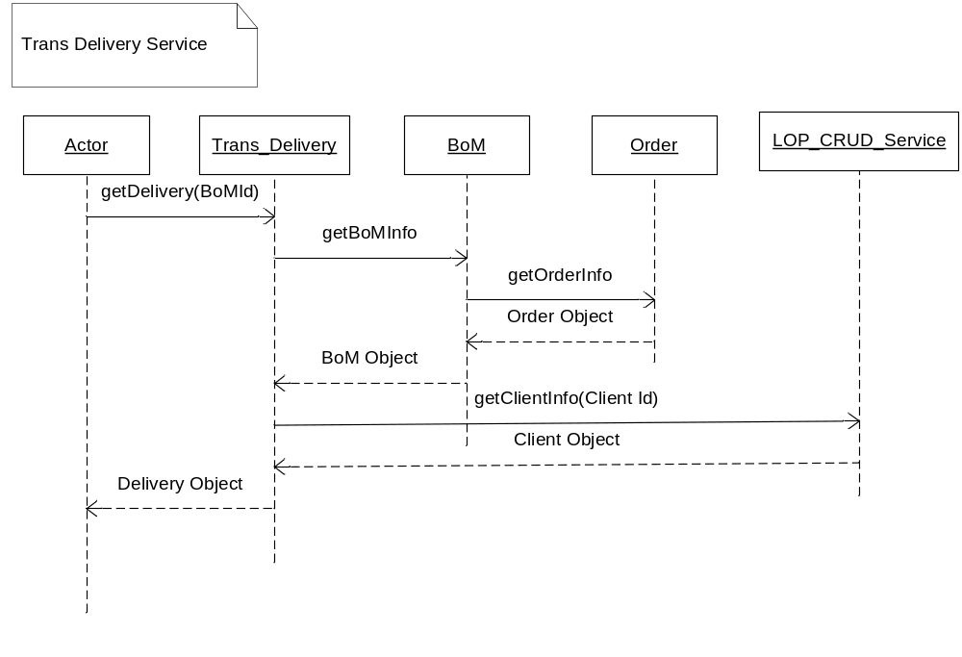

REQUIREMENTS TRACEABILITY MATRIX

E.D. # | External Design Functional Change | I.D. # | Internal Design Functional Change

FUNCTIONAL & LOGICAL SPECIFICATIONS

Steps in creating Process Plan (Iteration 2)

- User presses the “Submit for DataMart Creation” button on the Order delivery list screen.
- Web page calls the process plan action class passing in the BoM id of the BoM that is going to be submitted.
- The action class calls the Trans Delivery service requesting the delivery object for the BoM.
  - The Trans_Delivery service will call the BoM service to get the BoM detail. (This includes Order specific detail)
  - The Trans_delivery service will call the LOP_CRUD_service requesting a client object containing all of the client information for the client that the BoM pertains to.
- Once the action class gets the Delivery object it will call the Transaction Process Plan service. (This service will handle calling the individual services that are required for creating the process plan).
  - Trans_Explode_BoM service is called passing in the Delivery object to get detailed information about the BoM and creating the process plan object. This transaction service will handle the following 3 service calls.
    - Get PPlan Unique ID service is called first to get a unique identifier for the process plan that is being created. This needs to be done now so that files created by the calls to DMS and MAT will have a prefix that identifies it with this process plan.
    - GetDimInfo is called to DMS requesting Item, Venue and Time information for the given BoM.
    - GetMeasureInfo is a call to MAT requesting measure information for the given BoM.
  - Now the accumulated information (PPlan Object) is passed to the Process Plan Engine (ILOG kernel) to produce the XML representation of the process plan. (BRMS team will be developing this service)
  - Create_Process_Plan service is called to save the process plan information to Process plan database.
  - The FTP service is called to send the XML document to the Acxiom FTP site.

Service Detail

Service Trans_Delivery

This transaction service will be called by the PPlan Transaction service. It will assemble the detailed information for the Delivery. It will contain calls to the Read BoM service that will pull in both the BoM detail and Order detail. It will also contain a call to the getClientInfo method on the LOB_CRUD_service. This Transaction Delivery service will be used in later iteration to create the delivery object that is passed to IM for validation before it is passed to transaction process plan service. This is also why the Transaction process plan service should be taking in a delivery object instead of a BoM id.

Service Trans_ExplodeBoM

This transaction service will be called by the PPlan Transaction service. It will assemble the detailed information on the BoM and return a populated object. It will first call the GetPPlanUniqueId service to get a unique process plan identifier. This will be used as the prefix for the files that are created by the DMS and MAT service calls. (In later iteration this will need to be combined with a generation number to handle rerunning a process plan. This should be done when the FWO queue is implemented) Information on calling the DMS and MAT services can be found in the appendix of this document.

Prefix example “123.1.DIM” – “123” is a sample process plan id. “1” is the generation and “DIM” is the identifier indicating that these are dimension files created by the call to DMS. “MAT” can be used for the Call to MAT.

The call to MAT will need to be stubbed out for I2 because they will not be ready. We will still need to create some temporary code the will return the output defined in the appendix.

Service GetPPlanUniqueId

This service will be called by the Explode BoM service to get a unique key. This key will be used as a prefix to the dimension and measure files created by DMS and MAT and later to uniquely identify the process plan.

The unique number will be provided by an oracle sequence (or similar db2 object) created on the process plan database. (See database model section of document)

Sample SQL = select process_plan_seq.nextval from dual;

Input: None
Output: Integer value

PPlan Engine

This will be a java application that will be created by the BRMS team using the ILOG kernel. It will take in the Process plan object and return the XML representation of the process plan.

PPLan CRUD Service

This will be a service that will contain the following methods for creating, reading, updating and deleting a process plan from the process plan database.

savePPlan(PPlan Object)
deletePPlan(PPlanId)
getPPlan(PPlan Id)
UpdatePPlan(PPlan Object

FTP File Service

This will be a generic service that will be able to FTP any file to a specified FTP site. This service will be called by the PPlan Transaction service to copy the process plan created by the PPlan Engine to the Acxiom FTP site.

DESIGN ASSUMPTIONS.

Handling Nested Orders
Currently order can contain multiple data type (POS, Consumer, and Market Insight)
A BoM will consist of one and only one data type (nested order)
One process plan will be created for each BoM (Nested order occurrence)

FTP software
Currently there is no requirement for secured FTP, so the FTP API from jetty project will be leveraged to create the file FTP service.

DESIGN RISKS.

ARCHITECTURE IMPLICATIONS

DATABASE MODEL

It looks like one table will be required to save the process plans that are created.

Process Plan database

Data to be recoded per process plan
- Process plan Id
- BoM id
- Creation date
- XML document

Oracle sequence or DB2 equivalent to provide unique process plan Id used by the GetPPlanSeq service.

Client Info needed for Process Plan (need to determine where this information is persisted)
- Client_id
- db_host
- db_server
- db_port
- db_name
- db_user
- db_password
- as_host
- as_port
- as_user
- as_password

FTP detail should be stored in a database
- Acxiom FTP Site for Infoscan MK (iriftp.infores.com {iriftp.corp.acxiom.net})
- ID (dtmadmin)
- Password (nimda3)

QUALITY CONTROL

Exception Handling:
When an exception occurs while creating the process plan an error message will be passed back to the calling service and the details of the error will be logged to Jets as per QC framework standards . (Log details to be determined)

Note: Process plan service will need to clean up FTP site removing any files that are related to the failed process plan.

INTERNAL DESIGN SIGNOFF (AD Only)

Signoff - Name | Functional Area | Signoff Date

APPENDIXES

MAT service called GetMeasureInfo

The Explode BoM service will pass in a collection of measures to MAT along with an “as of date” so that the correct version of the files are produced. We will also pass in a prefix to user for naming the files that are produced (see input sample). MAT will return the following files.

<prefix>.DIM.MEAS.FACT (contains the fact file information that needs to be pulled from FDW. This will not be used for I2. For iteration two all fact information will be pulled)
<prefix>.DIM.MEAS.DETAIL (contains aggregation detail on measures)
<prefix>.DIM.MEAS.ASMODEL (contains information on measures required by AS MODEL)

<prefix>.DIM.MEAS.WEIGHTS.DATA (just for I2)
<prefix>.DIM.MEAS.WEIGHTS.META (just for I2)
<prefix>.DIM.MEAS.ACV.DATA (just for I2)
<prefix>.DIM.MEAS.ACV.META (just for I2)
<prefix>.DIM.MEAS.STORECOUNT.DATA (just for I2)
<prefix>.DIM.MEAS.STORECOUNT.META (just for I2)
<prefix>.DIM.MEAS.MOVEMENT.META (just for I2)

INPUT SAMPLE

<AS_OF_DATE>2005-9-2</AS_OF_DATE>
<FILE_PREFIX>123.1.DIM</FILE_PREFIX>
<OUT_FILE_LOCATION>
<FTP_SERVER>iriftp.corp.acxiom.net</FTP_SERVER>
<FTP_ID>test-id</FTP_ID>
<FTP_PSW>password</FPT_PSW>
<PATH>/iri/infoscan_mk/</PATH>
</OUT_FILE_LOCATION>
<MEASURE_LIST>
<MEASURE>SampleMeasure1Key</MEASURE>
<MEASURE>SampleMeasure2Key</MEASURE>
<MEASURE>SampleMeasure3Key</MEASURE>
<MEASURE>SampleMeasure4Key</MEASURE>
</MEASURE_LIST>

XML response from Service call will list the file that have been created with the provided prefix. Note for the highlighted file MAT is only providing the name of the file. This file itself will be produced by extraction section of the process plan.

<FILE_LIST>
<EXTRACTION_FILE>123.1.DIM.MEAS.FACTS</EXTRACTION_FILE>
<AGGREGATION_FILE>123.1.DIM.MEAS.DETAIL</ AGGREGATION_FILE >
<ASMODEL_FILE>123.1.DIM.MEAS.ASMODEL</ASMODEL_FILE >
<MOVEMENT>
<DATA_FILE>123.1.MOVEMENT.DATA</DATA_FILE>
<META_FILE>123.1.MOVEMENT.META</META_FILE>
</MOVEMENT>
<PROJECTION_FILES>
<ACV>
<DATA_FILE>123.1.DIM.MEAS.ACV.META</DATA_FILE>
<META_FILE>123.1.DIM.MEAS.ACV.META</META_FILE>
</ACV>
<STORECOUNT>
<DATA>123.1.DIM.MEAS.STORECOUNT.META</DATA>
<META>123.1.DIM.MEAS.STORECOUNT.META</META>
</STORECOUNT>
<WEIGHTS>
<DATA_FILE>123.1.DIM.MEAS.WEIGHTS.META</DATA_FILE>
<META_FILE>.1.DIM.MEAS.WEIGHTS.META</META_FILE>
</WEIGHTS>
</PROJECTION_FILES>
</FILE_LIST>

OUTPUT FILE SAMPLE (file_prefix.DIM.MEAS.FACTS)
This will not be used for I2 it will replace the movement data and meta files above
<DATASET>
<FILE name=”filename”/>
<KEY_COLUMNS>
<COLUMN name=”time” position=”1” raw_datatype=”int64” nullable=”false”/>
<COLUMN name=”venue” position=”2” raw_datatype=”int64” nullable=”false”/>
<COLUMN name=”item” position=”3” raw_datatype=”int64” nullable=”false”/>
</KEY_COLUMNS>
<FACT_COLUMNS>
<COLUMN name=”units” raw_datatype=”float64” position=”4” nullable=”true”>
</FACT_COLUMNS>
</DATASET>

DMS Service called GetDimInfo

OMS will make one request to a DMS service for Venue, Item and Time information. Here is a break down of the input and output of the DMS service.

(Note: One outstanding issue is the input DMS requires for time. Hard coded in DMS for I2)

INPUT

<?xml version="1.0"?>
<WS_GETDIMINFO_INPUT>
<DIMENSION type="ITEM">
<CATEGORY_KEY>1828283</CATEGORY_KEY>
</DIMENSION>

<DIMENSION type="VENUE">
<VENUE_GROUP_LIST>
<VENUE_GROUP_KEY>83838</VENUE_GROUP_KEY>
<VENUE_GROUP_KEY>83839</VENUE_GROUP_KEY>
</VENUE_GROUP_LIST>
</DIMENSION>
<AS_OF_DATE></AS_OF_DATE>
<FILE_PREFIX>123.1.DIM</FILE_PREFIX>
<OUT_FILE_LOCATION>
<FTP_SERVER>iriftp.corp.acxiom.net</FTP_SERVER>
<FTP_ID>test-id</FTP_ID>
<FTP_PSW>password</FTP_PSW>
<PATH>/iri/infoscan_mk/</PATH>
</OUT_FILE_LOCATION>
</WS_GETDIMINFO_INPUT>

OUTPUT

<?xml version="1.0"?>
<WS_GETDIMINFO_OUTPUT>
<DIMENSION type=”ITEM”>
<LEAF_LEVEL_KEYS>123.1.DIM.ITEM.KEYS</LEAF_LEVEL_KEYS>
<FILE_LIST>
<FILE>
<DUAL_KEY_FILE>123.1.DIM.ITEM.HIERARCHY.38383</DUAL_KEY_FILE>
<META_FILE>123.1.DIM.ITEM.META.383838</META_FILE>
</FILE>
<FILE>
<DUAL_KEY_FILE>123.1.DIM.ITEM.HIERARCHY.3878383</DUAL_KEY_FILE>
<META_FILE>123.1.DIM.ITEM.META.38773838</META_FILE>
</FILE>
…
</FILE_LIST>
<DIMENSION>
<DIMENSION type=”VENUE”>
<LEAF_LEVEL_KEYS>123.1.DIM.VENUE.KEYS</LEAF_LEVEL_KEYS>
<FILE_LIST>
<FILE>
<DUAL_KEY_FILE>123.1.DIM. VENUE.HIERARCHY.38383</DUAL_KEY_FILE>
<META_FILE>123.1.DIM. VENUE.META.383838</META_FILE>
</FILE>
<FILE>
<DUAL_KEY_FILE>123.1.DIM. VENUE.HIERARCHY.3878383</DUAL_KEY_FILE>
<META_FILE>123.1.DIM. VENUE.META.38773838</META_FILE>
</FILE>
…
</FILE_LIST>
<DIMENSION>
<DIMENSION type=”TIME”>
<LEAF_LEVEL_KEYS>123.1.DIM.TIME.KEYS</LEAF_LEVEL_KEYS>
<FILE_LIST>
<FILE>
<DUAL_KEY_FILE>123.1.DIM. TIME.HIERARCHY.38383</DUAL_KEY_FILE>
<META_FILE>123.1.DIM. TIME.META.383838</META_FILE>
</FILE>
<FILE>
<DUAL_KEY_FILE>123.1.DIM. TIME.HIERARCHY.3878383</DUAL_KEY_FILE>
<META_FILE>123.1.DIM. TIME.META.38773838</META_FILE>
</FILE>
…
</FILE_LIST>
<DIMENSION>
</WS_GETDIMINFO_OUTPUT>

FYI – The leaf level key files for Venue and Item will just be a list of keys. The leaf level key file for the time dimension however will be in the following format.

<TIME>
<TIME_START_KEY>18282</TIME_START_KEY>
<TIME_END_KEY>27822</TIME_END_KEY>
</TIME

DMS and MAT will be responsible for providing the names for the files. OMS will provide a prefix that will be applied to the beginning of the file name. This will indicate the occurrence of the process plan being processed. DMS will be responsible for insuring that the names do not collide within the given prefix.

Here is an example of one file naming convention

<prefix>. DIM.VENUE.KEYS
<prefix>. DIM.VENUE.HIERARCHY.<key>
<prefix>. DIM.VENUE.META.<key>
<prefix>. DIM.ITEM.KEYS
<prefix>. DIM.ITEM.HIERARCHY.<key>
<prefix>. DIM.ITEM.META.<key>
<prefix>. DIM.TIME.KEYS
<prefix>. DIM.TIME.HIERARCHY.<key>
<prefix>. DIM.TIME.META.<key>

XML Output expected from BRMS

Sample process plan using DMC’s control file model (XML)

Version 1.9

<PROCESS_PLAN id="123" gen="1">
<BOM_ID>38383</BOM_ID>
<ORDER_ID>83939</ORDER_ID>
<SIZE_ESTIMATE>SMALL</SIZE_ESTIMATE>
<EXTRACTION>
<harvester-params>
<paramlist
source="MK"
datatype="POS"
imputed="true"
deleted="true"
as_of="2005-9-2"
sort=""
convert_datafile="true"
stage=""
format_out="binary"
uselrd="true"
test="false"
granularity="WEEKLY"/>

<DIMENSION name="VENUE">
<LEAF_LEVEL_FILE name="123.1.DIM.VENUE.KEYS"/>
</DIMENSION>
<DIMENSION name="TIME">
<LEAF_LEVEL_FILE name="123.1.DIM.TIME.KEYS"/>
</DIMENSION>
<DIMENSION name="ITEM">
<LEAF_LEVEL_FILE name="123.1.DIM.ITEM.KEYS"/>
</DIMENSION>

<EXTRACTION_FILE name="123.1.DIM.MEAS.FACTS"/>

<OUTPUT>
<DATA_FILE name="123.1.MOVEMENT.DATA.1"/>
</OUTPUT>

</harvester-params>
</EXTRACTION>

<AGGREGATION>
<DIMENSION name="VENUE">
<HIERARCHY>
<HIERARCHY_FILE name="123.1.DIM.VENUE.HIERARCHY.3"/>
<META_FILE name="123.1.DIM.VENUE.META.3"/>
</HIERARCHY>
</DIMENSION>
<DIMENSION name="TIME">
<HIERARCHY>
<HIERARCHY_FILE name="123.1.DIM.TIME.HIERARCHY.38"/>
<META_FILE name="123.1.DIM.TIME.META.38"/>
</HIERARCHY>
</DIMENSION>
<DIMENSION name="ITEM">
<HIERARCHY>
<HIERARCHY_FILE name="123.1.DIM.ITEM.HIERARCHY.3838"/>
<META_FILE name="123.1.DIM.ITEM.META.3838"/>
</HIERARCHY>
<HIERARCHY>
<HIERARCHY_FILE name="123.1.DIM.ITEM.HIERARCHY.37838"/>
<META_FILE name="123.1.DIM.ITEM.META.37838"/>
</HIERARCHY>
<HIERARCHY>
<HIERARCHY_FILE name="123.1.DIM.ITEM.HIERARCHY.378381"/>
<META_FILE name="123.1.DIM.ITEM.META.378381"/>
</HIERARCHY>
</DIMENSION>
<MEASURES>
<DETAIL_FILE name="123.1.DIM.MEAS.DETAIL"/>
</MEASURES>
<PROJECTION_FILES>
<ACV>
<DATA_FILE name="123.1.DIM.MEAS.ACV.META"/>
<META_FILE name="123.1.DIM.MEAS.ACV.META"/>
</ACV>
<STORECOUNT>
<DATA_FILE name="123.1.DIM.MEAS.STORECOUNT.META"/>
<META_FILE name="123.1.DIM.MEAS.STORECOUNT.META"/>
</STORECOUNT>
<WEIGHTS>
<DATA_FILE name="123.1.DIM.MEAS.WEIGHTS.META"/>
<META_FILE name="123.1.DIM.MEAS.WEIGHTS.META"/>
</WEIGHTS>
</PROJECTION_FILES>

</AGGREGATION>

<DB_LOAD_AS_MODEL_EXEC>
<JOB_INFO>
<CLIENT_ID>1</CLIENT_ID>
<ORDER_NUMBER>2</ORDER_NUMBER>
<DELIVERY_ID>2</DELIVERY_ID>
<DELIVERY_TYPE>Initial</DELIVERY_TYPE>
<DB_HOST>roadrunner</DB_HOST>
<DB_SERVER>DYN</DB_SERVER>
<DB_PORT>1526</DB_PORT>
<DB_NAME>wasgh</DB_NAME>
<DB_USER>wasgh</DB_USER>
<DB_PASSWORD>welcome</DB_PASSWORD>
<AS_HOST>symdev2</AS_HOST>
<AS_PORT>12345</AS_PORT>
<AS_USER>superuser</AS_USER>
<AS_PASSWORD></AS_PASSWORD>
<AS_MODEL>MK_ITERATION_2</AS_MODEL>
</JOB_INFO>
<SCHEMA/>
<ASSOCIATED_FILE_INVENTORY>
<DIMENSION name="VENUE">
<HIERARCHY>
<HIERARCHY_FILE name= "123.1.DIM.VENUE.HIERARCHY.3"/>
<META_FILE name="123.1.DIM.VENUE.META.3"/>
</HIERARCHY>
</DIMENSION>
<DIMENSION name="TIME">
<HIERARCHY>
<HIERARCHY_FILE name= "123.1.DIM.TIME.HIERARCHY.38"/>
<META_FILE name="123.1.DIM.TIME.META.38"/>
</HIERARCHY>
</DIMENSION>
<DIMENSION name="ITEM">
<HIERARCHY>
<HIERARCHY_FILE name= "123.1.DIM.ITEM.HIERARCHY.3838"/>
<META_FILE name="123.1.DIM.ITEM.META.3838"/>
</HIERARCHY>
<HIERARCHY>
<HIERARCHY_FILE name= "123.1.DIM.ITEM.HIERARCHY.37838"/>
<META_FILE name="123.1.DIM.ITEM.META.37838"/>
</HIERARCHY>
<HIERARCHY>
<HIERARCHY_FILE name= "123.1.DIM.ITEM.HIERARCHY.378381"/>
<META_FILE name="123.1.DIM.ITEM.META.378381"/>
</HIERARCHY>
</DIMENSION>
<FACT/>
</ASSOCIATED_FILE_INVENTORY>
<MEASURES>
<ASMODEL_FILE name="123.1.DIM.MEAS.ASMODEL"/>
</MEASURES>
<MODEL_ACCESSORS/>
<SCOPING/>
</DB_LOAD_AS_MODEL_EXEC>

</PROCESS_PLAN>

